**8 Steps to a Healthy Venue**

WHAT WE’RE DOING TO KEEP OUR CUSTOMERS SAFE

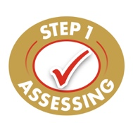

**Health and Safety Risk Assessment**

**We have carried out a health and safety risk assessment and implemented strict controls to reduce the risk of COVID-19 transmission in these premises.**

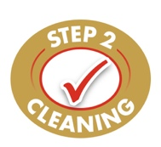

**Enhanced Cleaning Procedures**

**We have increased the level of cleaning to ensure that surfaces are adequately disinfected, high traffic areas are frequently sanitised, and food is prepared and served in compliance with the highest health and safety standards.**

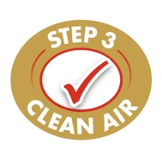

**Air Cleaning Technology**

**Air and surface sanitisers have been installed throughout these premises to remove airborne viruses   
and bacteria. These wall-mounted units work continuously to create and maintain healthy clean   
air environments.**

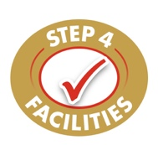

**Additional Hand Wash Facilities**

**Contactless hand washing facilities have been installed for staff and customer safety– to reduce touchpoints and prevent cross-contamination. Please use the basins and/or sanitisers provided, on   
your arrival and throughout your visit.**

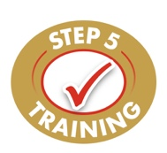

**Frequent Team Training**

**All staff have undertaken comprehensive training on cleaning procedures and COVID-19 – the risks and how to reduce transmission. Regular updates and re-training are given in line with food safety laws   
and current government guidance.**

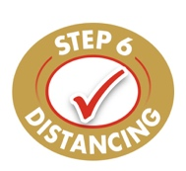

**Reduced Physical Contact**

**We have removed unnecessary contact between team members and customers. Our staff arrive at different times, remain socially distanced, and wear face masks as required. We request that you pay   
by card where possible and respect all social distance signage.**

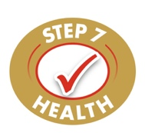

**Daily Health Screenings**

**All staff are required to successfully complete a health screening before attending these premises.   
The temperatures of all employees are taken on arrival, and masks, gloves and aprons are available   
as required.**

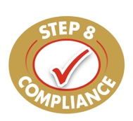

**Compliance with Current Covid Rules**

**For the safety of everyone, all staff and customers will be asked to comply with current regional rules   
and restrictions, unless individually exempt.**

01/2022 (HG0015)